INITIAL CONFIGURATION CODE:

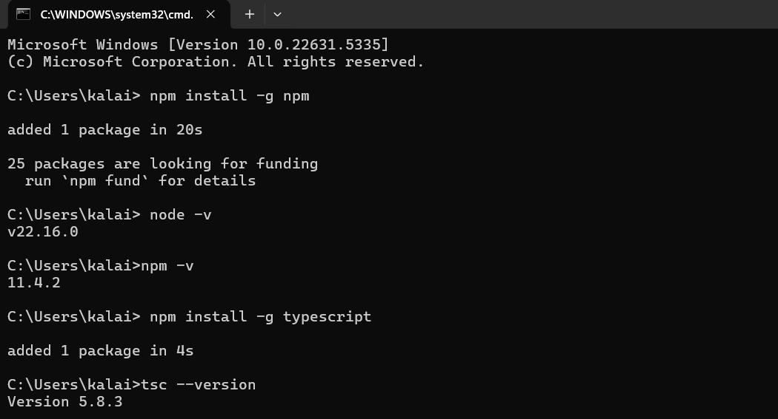

QUES 1 :

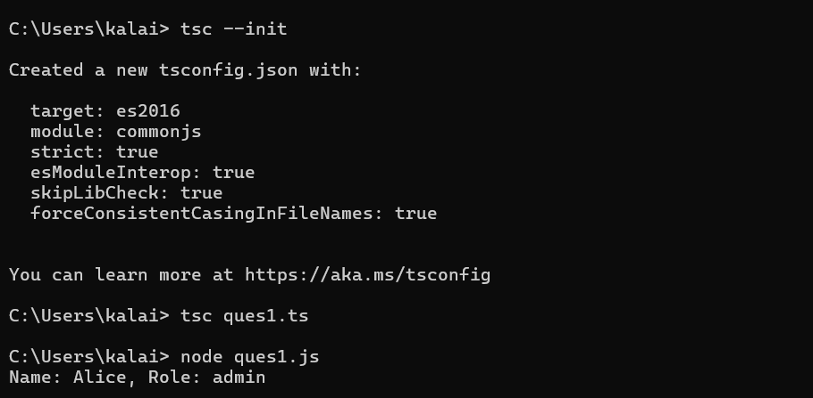

QUES 2:

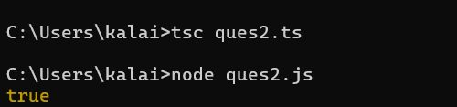

QUES 3:

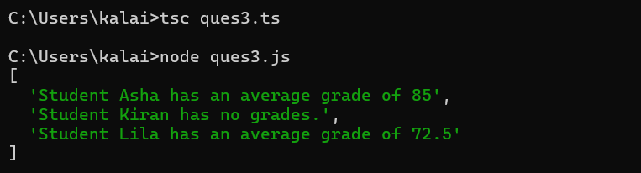

QUES 4:

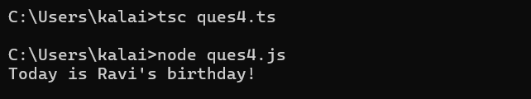

QUES 5:

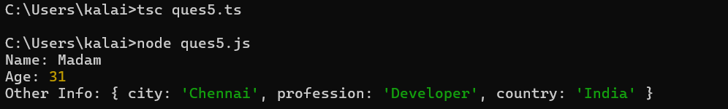

QUES 6:







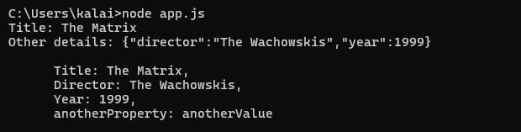

QUES 7:







QUES 8:



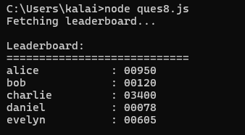

QUES 9:



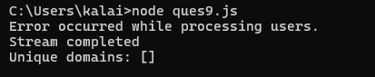

QUES 10:



